#YorkTalkMoney fortnight – 30 October - 11 November 2023
To support residents through the ongoing cost of living crisis, we’ve updated our Talk Money York toolkit. This is being issued to support Talk Money Fortnight from 30 October to 11 November.
Following you’ll find:
- Copy for your newsletters / intranets
- Social media graphics
- Text for social media posts to copy and paste
- Links to further information, online tools, sources of advice.
Thank you for sharing this toolkit. Working together, we hope to help improve residents’ financial situation.
All information can be found at www.livewellyork.co.uk/TalkMoney
Content for newsletters/intranets #YorkTalkMoney

As the ongoing cost of living crisis is forcing many households to make difficult decisions, City of York Council and partners are holding Talk Money Fortnight from 30 October to 11 November.
For some, pay rises are easing the cost of living. Mortgage holders and tenants are relieved that interest rate rises are on hold. However, higher interest rates have added pressure to many businesses, leading to job losses which are expected to increase further. Food prices and fuel costs are continuing to rise making it more difficult to budget.
To support people through this worrying time, a partnership of money experts has come together again to host Talk Money, a fortnight of activities, events and signposting to resources. Together, we’ll be supporting residents to maximise their income, manage household budgets, stay on top of bills and payments, cut costs and advice on building up savings.
To help meet still-rising expenses, households are urged to check if they are eligible for any benefits or allowances to maximise their income. This could include Pension Credit which is available even for those who own their home and have savings and brings additional benefits. It includes applying for free school meals too which bring further help with uniforms and extra money to support your child’s schooling.
For more money advice and information, please visit www.livewellyork.co.uk/talkmoney.
Ends

Social media toolkit for partners to share
#YorkTalkMoney

Please help us to signpost online resources and events to your and partners and networks.

We have drafted the following Facebook and Twitter posts and would be grateful if you would share these (as appropriate) through your social media channels generally, tagging in campaign partners and others who can amplify the messages. Please use our hashtag #YorkTalkMoney to help us evaluate campaign reach and engagement, and #HelpForHouseholds to signpost people to more help.

Please also tag in your partners including @CityofYork and on Twitter @livewellyork

Facebook/Twitter |  | Twitter |  | Image
Talk Money fortnight urges everyone to take control of their money!  Pick up hints, tips, advice and support to:  - Feel more confident about managing your money;  - Know where to get good information and advice  - Know what financial support is available and how to get it  - Get the best deal on your gas, electricity and internet bills  - Find good debt advice.  Find out more at www.livewellyork.co.uk/talkmoney |  | Talk Money fortnight urges everyone to take control of their money!  Pick up hints, tips, advice and support to:  - Feel more confident about managing your money;  - Get good information & advice  - Know what financial support is available & how to get it  - Get the best deal on your gas, electricity and internet bills  - Find good debt advice www.livewellyork.co.uk/talkmoney  #YorkTalkMoney |  | 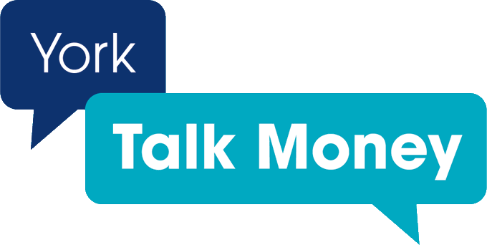
Budgeting can help you stay on top of your bills and save £1,000s.  Use a Budget Planner to track your finances and identify simple changes you can make.  Start by listing your needs – your rent or mortgage, and other essentials like gas and electricity.  Dividing your money into separate pots for different expenses is a great way to make sure your bills are covered and your money goes exactly where you want it to.  Find more information about Living on a budget |  | Budgeting can help you stay on top of your bills and save £1,000s.  Use a Budget Planner to track your finances and identify simple changes you can make.  Find more information about Living on a budget  #YorkTalkMoney |  | 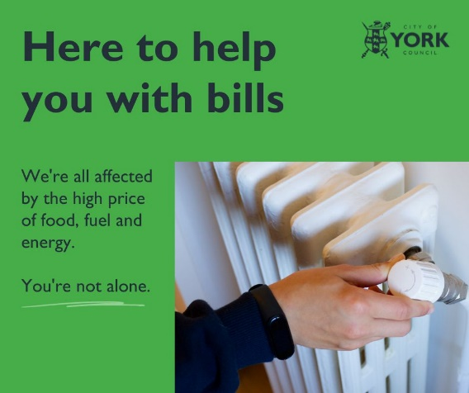
Is your household income feeling squeezed?  Check you’re getting all the benefits or grants you might be entitled to.  Find out:  • what benefits you could get  • how to claim  • how your benefits will be affected if you start work  using the free and anonymous Benefits calculators (GOV.UK) | Is your household income feeling squeezed?  Check you’re getting all the benefits or grants you might be entitled to.  Find out:  • what benefits you could get  • how to claim  • how your benefits will be affected if you start work  using the free and anonymous Benefits calculators (GOV.UK)  #HelpforHouseholds  #YorkTalkMoney |  | 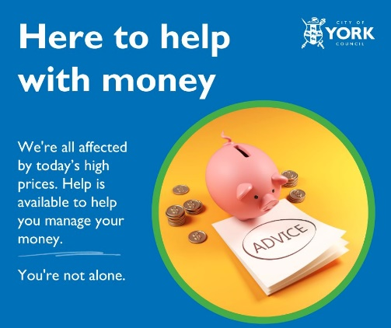
Get the money that you are entitled to.  Financial support and benefits for residents who are struggling or have an emergency.  Additional local support is available at: www.york.gov.uk/benefits www.livewellyork.co.uk/talkmoney  Or ask at your local community venue or library | Get the money that you are entitled to.  Financial support and benefits for residents who are struggling or have an emergency.  Additional local support is available at: www.york.gov.uk/benefits www.livewellyork.co.uk/talkmoney  Or ask at your local community venue or library |  | 
Help cut your gas and electricity bills!  If your home is draughty and your household income’s £30k pa or less, we’ve got grants for you.  Whether you rent privately or own your home, we can help with insulation grants to help cut your energy costs.  Visit www.york.gov.uk/EnergyEfficiency | Help cut your gas and electricity bills!  If your home is draughty and your household income’s £30k pa or less, we’ve got grants for you.  Whether you rent privately or own your home, we can help with insulation grants to help cut your energy costs.  Visit www.york.gov.uk/EnergyEfficiency |  | 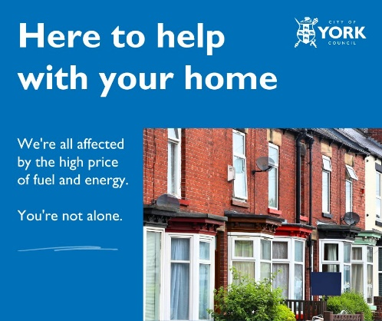
Quick and easy ways to save energy can lower your bills - and cut your carbon footprint.  Whether you’re a homeowner, a private or social renter, a student, there are many things you can do.  Follow these steps and see what you can save: https://energysavingtrust.org.uk/hub/quick-tips-to-save-energy/ | Quick and easy ways to save energy can lower your bills - and cut your carbon footprint.  Whether you’re a homeowner, a private or social renter, a student there are many things you can do.  Follow these steps and see what you can save: https://energysavingtrust.org.uk/hub/quick-tips-to-save-energy/ |  | 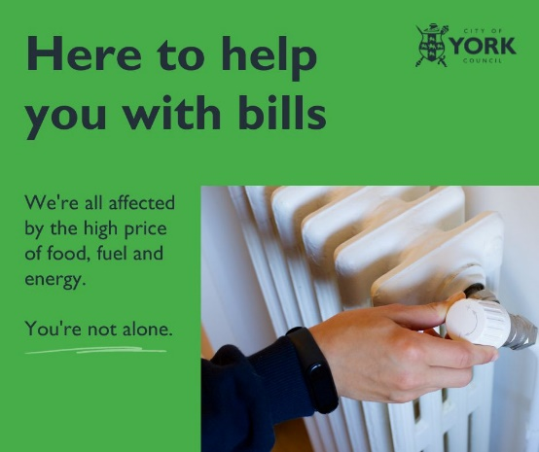
If you or someone you know can’t afford to heat their home help is available.  Find out what to do if you are struggling with your energy bills.  https://www.nea.org.uk/get-help/key-things-to-do-if-you-are-struggling-with-your-energy-bills | If you or someone you know can’t afford to heat their home help is available.  Find out what to do if you are struggling with your energy bills.  https://www.nea.org.uk/get-help/key-things-to-do-if-you-are-struggling-with-your-energy-bills
Plan early for Christmas, to avoid spending a fortune over the festive period.  This isn't about early celebration, it's about preparation.  There are sackfuls of things you can do now to reduce the financial stress and avoid being broke in January.  www.moneysavingexpert.com/shopping/christmas-savings/ | Plan early for Christmas, to avoid spending a fortune over the festive period.  This isn't about early celebration, it's about preparation.  There are sackfuls of things you can do now to reduce the financial stress and avoid being broke in January.  www.moneysavingexpert.com/shopping/christmas-savings/ |  | 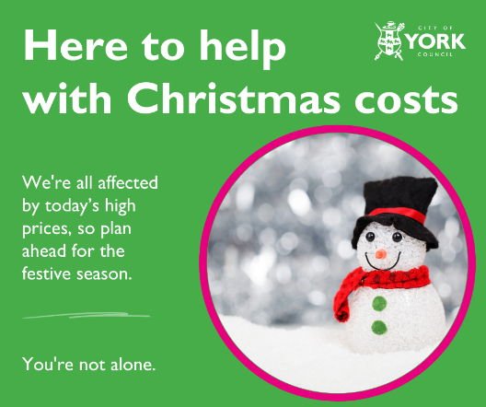
Money worries can hit your mental wellbeing.  If you’re experiencing problems with low mood or anxiety there is support at hand.  In York there are a number of talking therapies and self-help approaches for these common mental health problems.  Anyone aged 16 or over who’s registered with a GP in York can self-refer online https://yorkandselbyiapt.co.uk or by calling 01904 556840 | Money worries can hit your mental wellbeing.  If you’re experiencing low moods or anxiety, there is support at: https://yorkandselbyiapt.co.uk or by calling 01904 556840  #YorkTalkMoney |  | 
Before borrowing, taking out a loan or using credit cards:  - spend time shopping around,  - work out your budget  - never borrow money on the spur of the moment.  - be careful about borrowing more money to pay off existing debts.  - avoid going overdrawn on your bank account without agreement.  - don't borrow from loan sharks – speak to a Credit Union instead.  Check out Citizens Advice guide for more | Before borrowing, taking out a loan or using credit cards:  - spend time shopping around,  - work out your budget  - never borrow money on the spur of the moment.  - be careful about borrowing more money to pay off existing debts.  - avoid going overdrawn on your bank account without agreement.  - don't borrow from loan sharks – speak to a Credit Union instead.  Check out Citizens Advice guide for more |  | 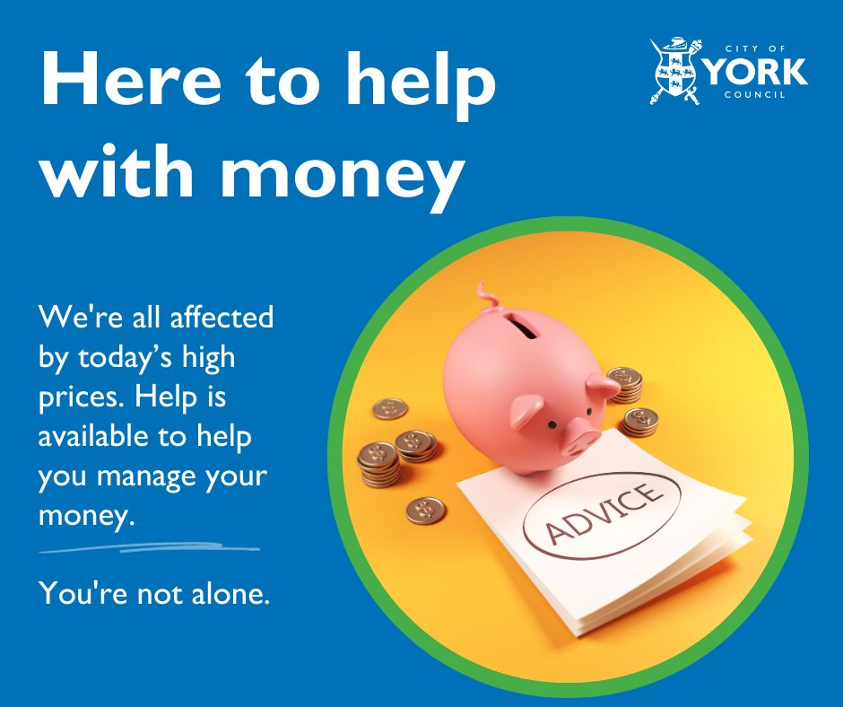
Saving smaller, regular amounts lets you budget your spending from week to week, or month to month more effectively.  Every bit makes a big difference.  Setting a savings goal is a great way to start. Find out where to start and what a suitable savings goal is for you.  Or check out Help to Save. It pays a 50% bonus on the amount saved, up to £1,200 over 4 years. | Saving smaller, regular amounts lets you budget your spending from week to week, or month to month more effectively.  Every bit makes a big difference.  Find out where to start and what a suitable savings goal is for you.  Or check out Help to Save. It pays a 50% bonus on the amount saved, up to £1,200 over 4 years.  #YorkTalkMoney |  | 
Credit unions are financial co-operatives that offer a safe and secure place for people to save and borrow.  You can join credit unions to save regularly or apply for legal, affordable loans, when emergencies arise.  York residents can Open a Community First Credit Union savings account today and get a £25 savings bonus | Credit unions are financial co-operatives that offer a safe and secure place for people to save and borrow.  You can join credit unions to save regularly or apply for legal, affordable loans, when emergencies arise.  York residents can Open a Community First Credit Union savings account today and get a £25 savings bonus.  #YorkTalkMoney |  | 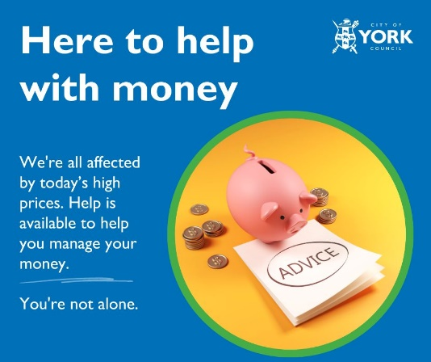
.@LoanSharkNews support victims of illegal money lending.  For advice and support, call the confidential Stop Loan Sharks Helpline on 0300 555 2222.  Live chat is available 9am-5pm weekdays at www.stoploansharks.co.uk | .@LoanSharkNews support victims of illegal money lending.  For advice and support, call the confidential Stop Loan Sharks Helpline on 0300 555 2222  Live chat is available 9am-5pm weekdays at www.stoploansharks.co.uk  #YorkTalkMoney |  | 
Tips to spot and avoid loan sharks:  - Check your lender is @TheFCA authorised  - Report illegal money lenders to @LoanSharkNews  - Contact your local credit union about safe savings and affordable loans at www.findyourcreditunion.co.uk  Help is a call away at www.stoploansharks.co.uk | Tips to spot and avoid loan sharks:  - Check your lender is @TheFCA authorised  - Report illegal money lenders to @LoanSharkNews  - Contact your local credit union about safe savings and affordable loans www.findyourcreditunion.co.uk  Help is a call away at www.stoploansharks.co.uk  #YorkTalkMoney |  | 
Do you know someone struggling to afford reliable broadband and phone services?  Do they also receive government benefits? They could be eligible for low-cost, reliable broadband and mobile phone packages.  To find out what deals are available, visit ofcom.org.uk/cheap-broadband. | Do you know someone struggling to afford reliable broadband and phone services?  Do they also receive government benefits? They could be eligible for low-cost, reliable broadband and mobile phone packages.  To find out what deals are available, visit ofcom.org.uk/cheap-broadband. #HelpForHouseholds  #YorkTalkMoney |  | 
If you need to talk to someone about money but aren’t sure how it will go, the How to talk about money guide will help you get started.  It includes tips on how to get a good outcome, share money goals and what to do if you think the conversation may be tricky – or if it doesn’t go as planned. | If you need to talk to someone about money but aren’t sure how it will go, the How to talk about money guide will help you get started.  It includes tips on how to get a good outcome, share money goals and what to do if you think the conversation may be tricky – or if it doesn’t go as planned.  #YorkTalkMoney

ENDS

