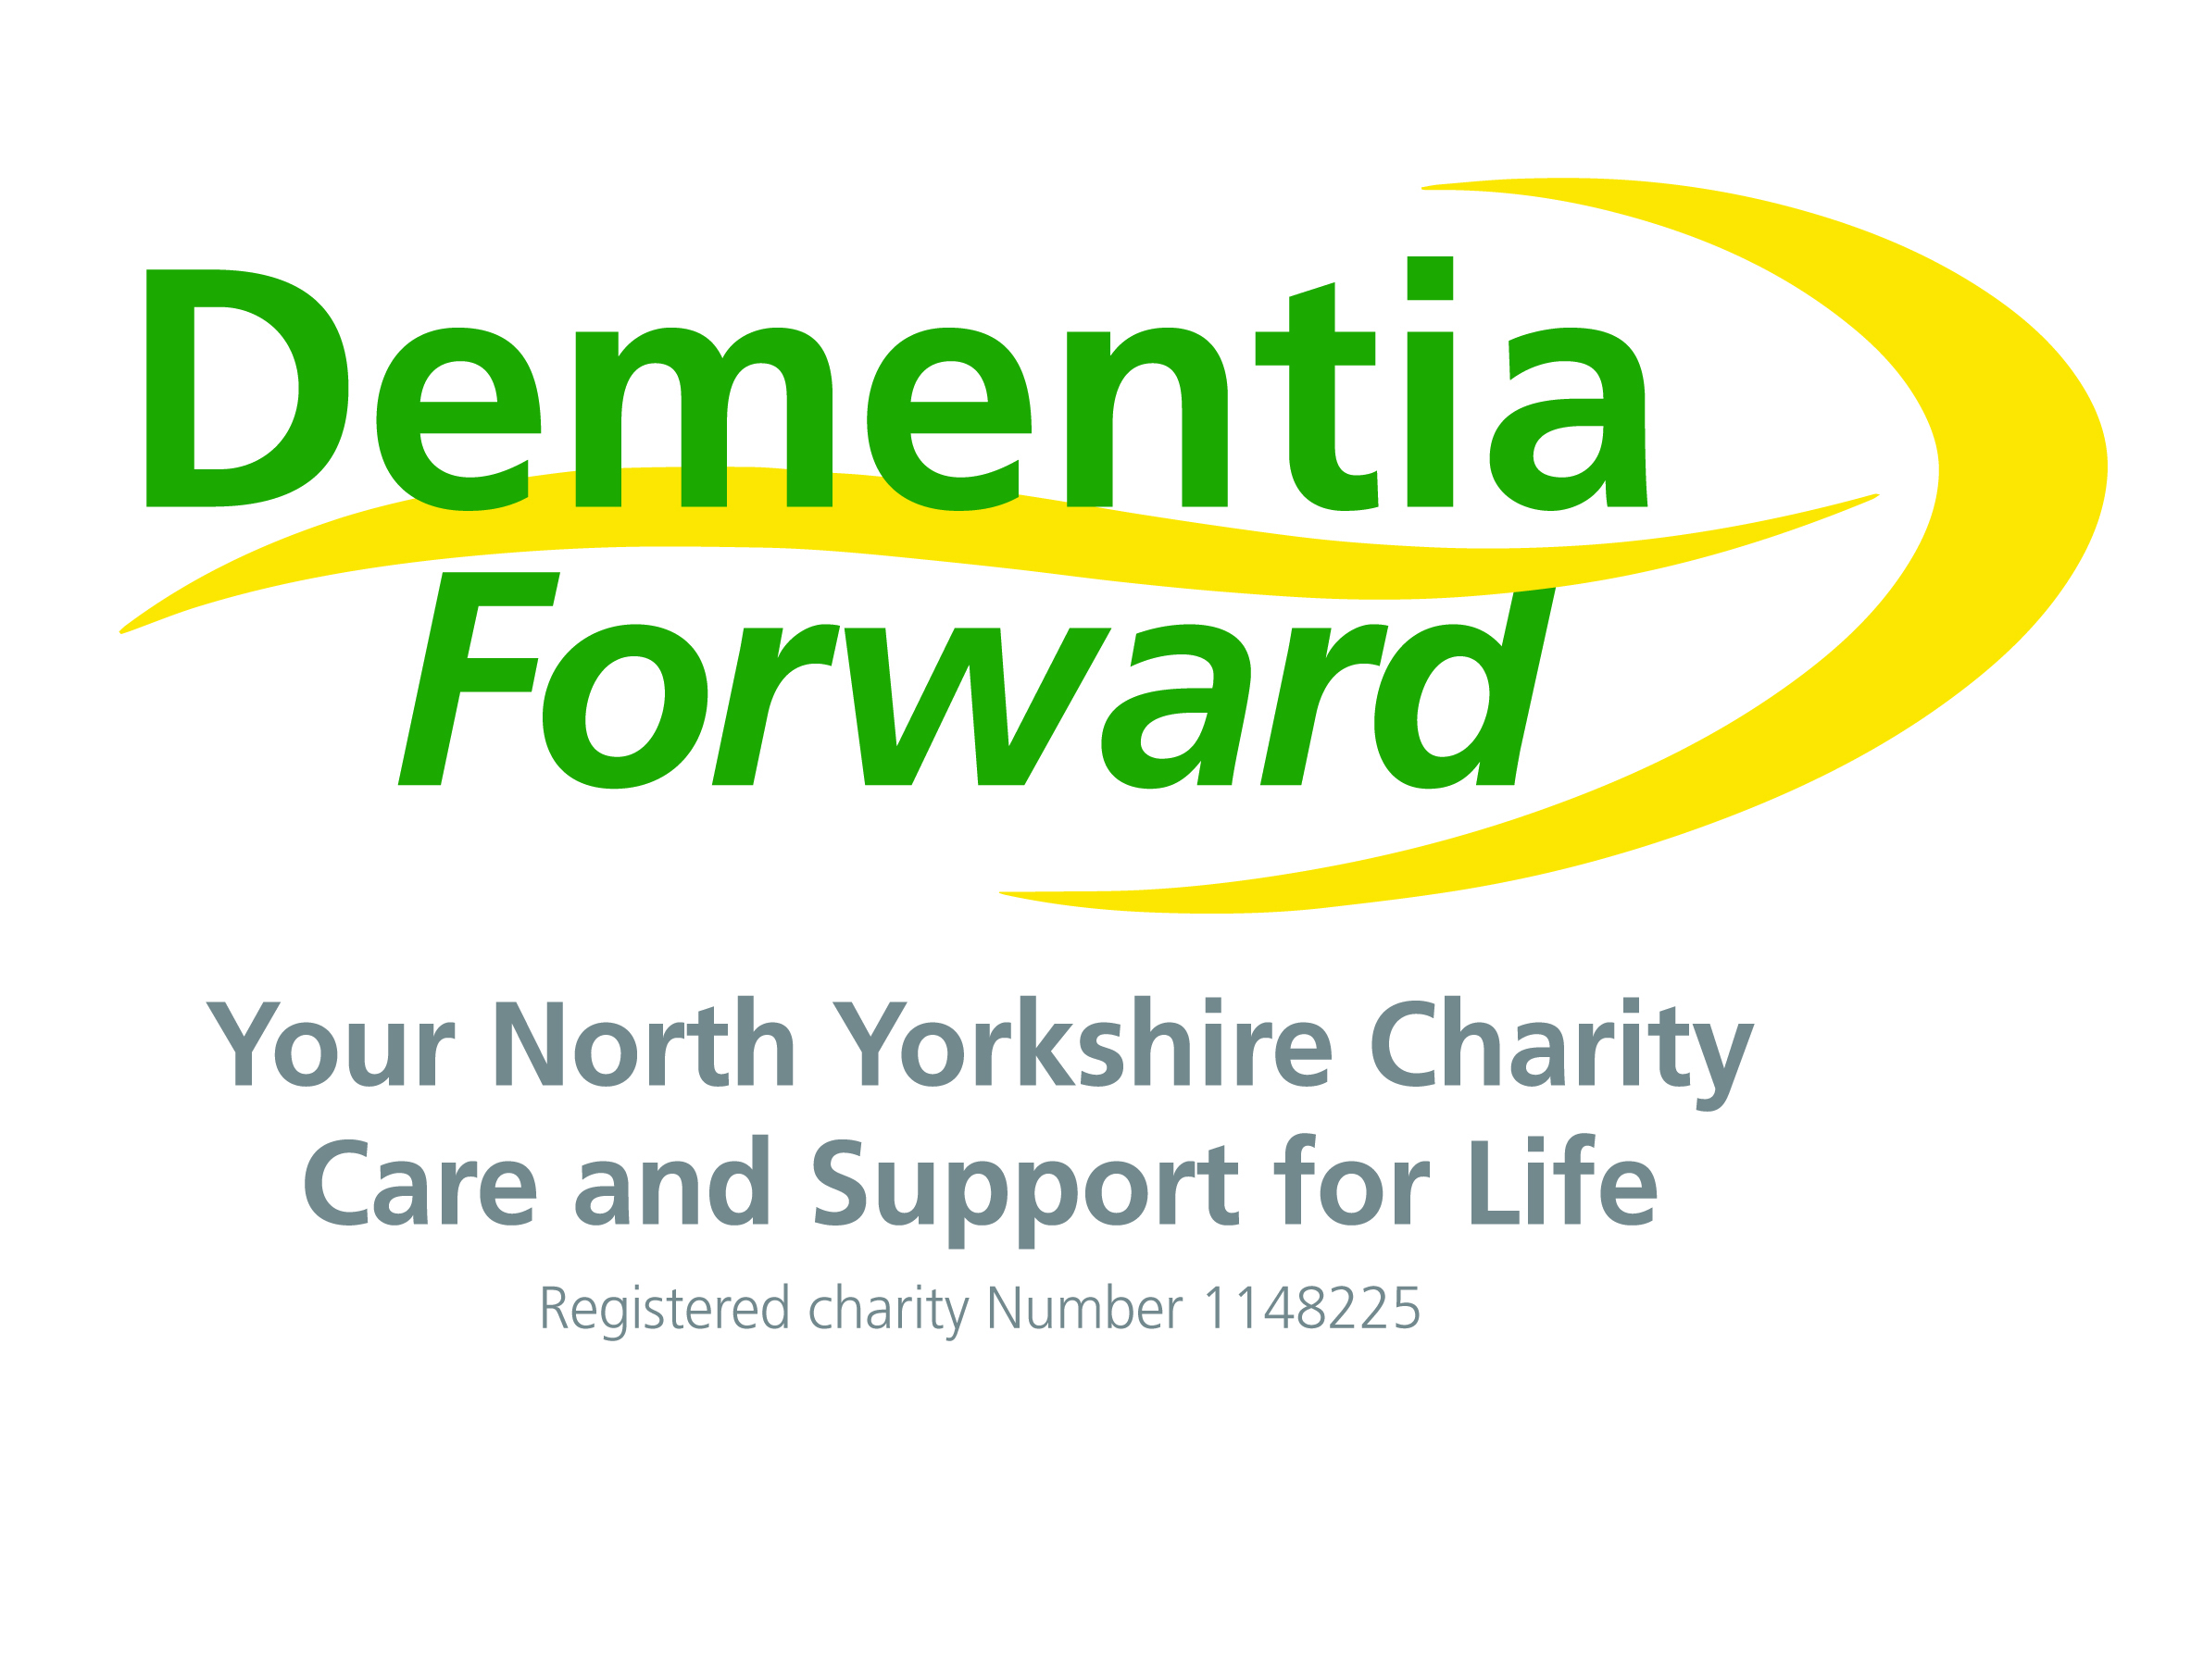
Dementia Forward
Volunteer Enquiry Form
Office use only: Outcome:
Received date……………... □ V2 booked date …………………….. With…………………….. Location …………………………

Actioned By……………. □ Not Proceeding
□ Other

Received / actioned: Added to database:

Title: First Name(s): Surname:
Known as:

Postcode (we ask this information so that we can direct your enquiry to the appropriate service for your area):

Home Phone: Mobile:

Email Address:

Occupation:

How did your hear about us?
Have you seen a specific vacancy advertised?
Please tick the boxes which represent areas of volunteering interest:
Singing  Social & group activities | Administration  Campaigning, media & PR | Well-being activities | Fundraising
I am unsure where I can help, please provide me with more information.

When are you available to volunteer?

Please tell us about your skills & experience:

Do you have any other useful skills, even if they are not directly related to the role i.e. sign language, manicuring, tai chi, another language, professional:

Hobbies, interests and things you particularly enjoy, such as knitting, yoga, rag rugging, painting, snooker, golf:

What attracted you to Dementia Forward?

I understand that my details will be held on Dementia Forward’s database in line with their privacy policy and that this information will be used for purposes related to my volunteer enquiry.
Signed:
Date:

