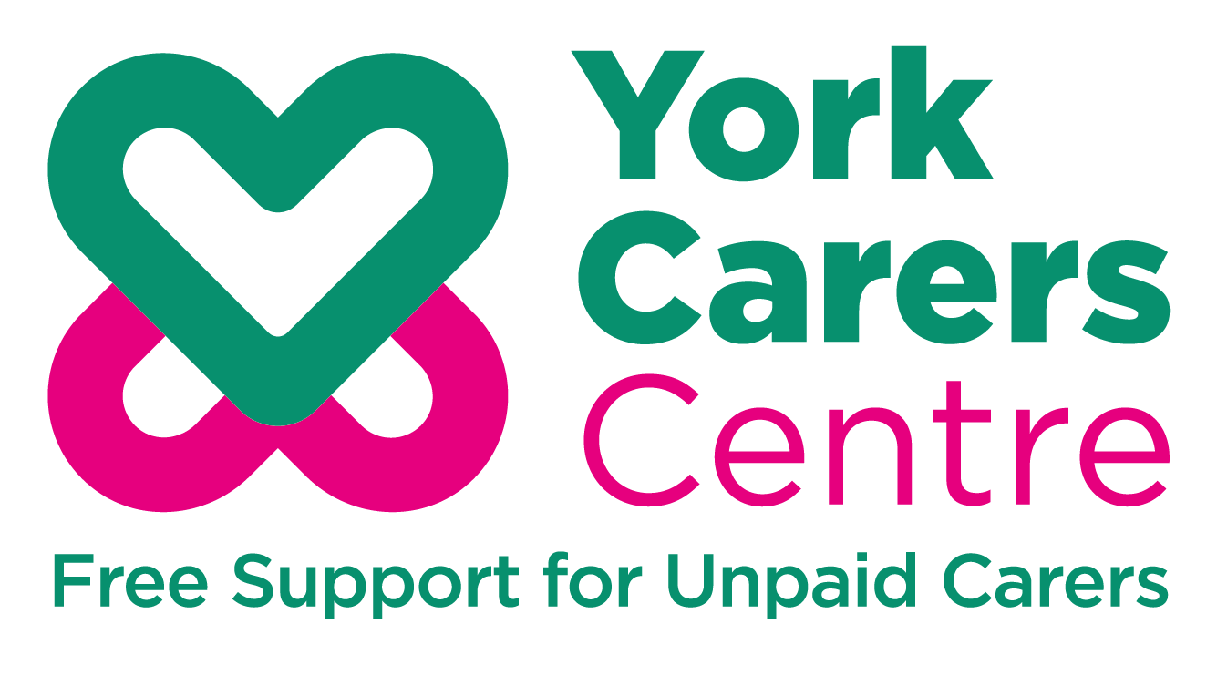

Volunteer Application Form

York Carers Centre
Volunteer Application Form
Name
Address

Email
Phone
Next of Kin Name
Next of Kin Telephone

I would like to help out with carers: (please indicate Y or N or circle)
- Face to face
- Via telephone
- One to one
- In groups
- By raising awareness
- With admin tasks

I am available: (please indicate Y or N or circle)
- Mondays
- Tuesdays
- Wednesdays
- Thursdays
- Fridays

I am available for: (please indicate Y or N or circle)
- 3 Months
- 6 months
- 12 months+

I am interested in volunteering with: (please indicate Y or N or circle)
- Young Carers
- Young Adult Carers
- Adult Carers

The volunteer role I am particularly interested in is:
..................................................................................... (name of role)

Please provide a paragraph about why you would make a good volunteer (this can include your skills, knowledge and/or understanding of carers or why you want to volunteer with us)

I can start volunteering (please indicate date)……………………………
I have a transferrable DBS (please indicate Yes or No)…………………..
I can provide references (please indicate Yes or No)…………………..

Please email this form directly to York Carers Centre
volunteering@yorkcarerscentre.co.uk
or post to: York Carers Centre, 17 Priory Street, York YO1 6ET
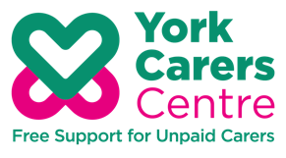


Registered Charity No. 1127644 Company No. 06760783

