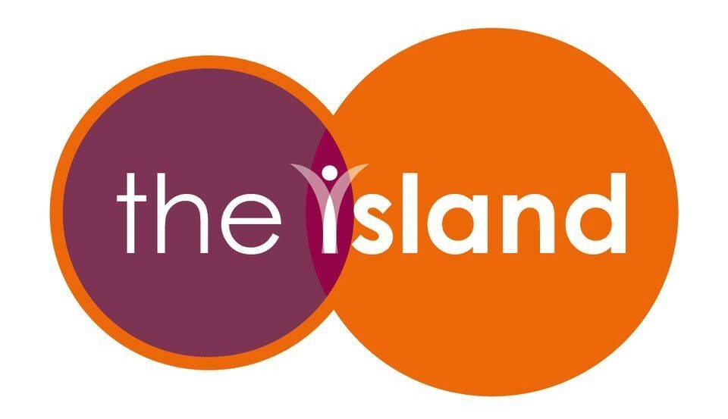

The Island

Job Title: Youth Sessional Worker
Location: York, variable delivery locations with office based in Huntington
Contract type: 5-hours per week. Temporary 9-month contract with possibility to extend.
Pay Rate: £15 per hour.

About The Island
The Island has been dedicated to supporting children and young people aged 8 to 18 through tailored mentoring services for two decades. Over the years, we have provided life-changing support to over 3,000 children and young people, supporting them to build confidence, resilience, and brighter futures.
At The Island, we believe that every young person deserves a positive role model. Our core 1-1 mentoring programme is delivered in a variety of formats, from short-term targeted support to long-term mentoring relationships and group programmes. Each approach is carefully tailored to the individual, responding to their unique needs and empowering them to thrive socially, emotionally, and academically.
Now is a crucial time in the Charity’s development. Following a strategic decision to return to being a community-based youth work organisation, we are looking to the future and re-instating our Youth Group provision.
This role forms part of The Island’s Service Team. As a small, community-based organisation, this is an exciting opportunity to help shape the future of the Charity alongside a passionate and dedicated team.

About the role
Our group’s service will link children and young people actively engaged in The Islands mentoring service with structured group support. These programmes offer both pastoral and practical support within a peer-based environment, including youth groups and peer support groups.
Working closely with the Family and Groups Coordinator, you will contribute to the development and delivery of The Islands’ expanding group programmes, providing wellbeing-focused, creative and physical activities for cohorts of young people involved in mentoring.

Main responsibilities
- Co-facilitate youth group sessions, supporting the delivery of engaging activities for children and young people involved in The Islands mentoring programme.
- Manage on-the-day session logistics to ensure well-run sessions.
- Ensure the safety and well-being of all children and young people through adherence to The Islands policies and procedures.
- Complete all relevant session paperwork, including a session record document and safeguarding concerns record.
- Bring a compassionate, supportive, and youth-centred approach to all work.
- Work directly with children and young people to support the development of their social skills.
- Bring positive energy and enthusiasm to build strong relationships with young people, their families, and the wider team at The Island.
- Work flexibly and inclusively to meet the needs of young people who are disadvantaged, experience discrimination, or have additional learning needs.
- Attend a monthly 1-1 session with line manager.

Person Specification
Experience of working with children and young people aged 8–18 from a wide range of backgrounds, including those with additional or challenging needs. | Essential
Ability to build motivating, supportive and trusting relationships, respond to individual learning needs, and confidently manage challenging behaviour and situations. | Essential
Knowledge of youth organisations, youth provision and the youth sector. | Essential
Experience of delivering activities, projects, outings and group work for children and young people. | Essential
Ability to work collaboratively as part of a team and alongside volunteers. | Essential
Sound understanding of youth work principles and the issues affecting young people. | Essential
Strong understanding of safeguarding practices, with Level 3 safeguarding knowledge or a willingness to complete the qualification. | Essential
Ability to transport session materials from Huntington, York, and deliver sessions in person across a range of locations. | Essential
IT proficiency in MS Office applications and familiarity with CRM software. | Essential
Hold a First Aid qualification and a Level 2 Youth Work qualification (or equivalent). | Desirable
Can deliver a specialist skill that can be used within youth sessions, such as sport, arts and crafts, music, or another creative or physical activity. | Desirable

