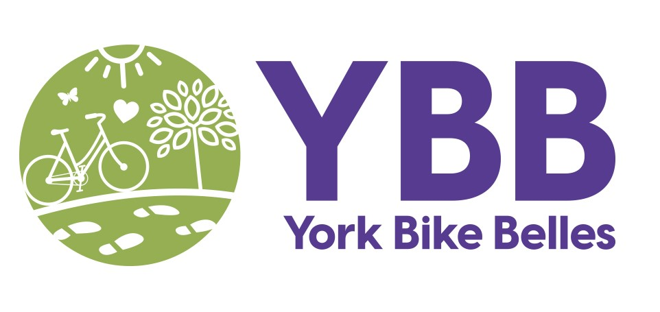
Title: Life's Better By Bike! Project Officer
Organisation: York Bike Belles CIC (YBB)
Overview:
Life's Better By Bike is an exciting new project to enrich the lives of people in York by increasing levels of cycling especially in underrepresented groups, such as women, older adults and people with health conditions.
Based on the number of enquiries we receive, we feel that the one of the greatest unmet cycling needs in York is personalised support for people of all ages, abilities and life situations into cycling. This project will restart various cycling activities to meet this need. This includes our popular start cycling with cake confidence service - a 12-week learn to ride tailored pathway into cycling with advice, bike loans, cycle training and one-to-one buddying. We will also restart regular Nature Rides and socials, accessible Cycling Without Age (CWA) rides, bike maintenance workshops and develop cycling volunteers. Do have a look at our cycling work currently on hold at www.yorkbikebelles.community.
The Project Officer will lead on delivering the project activities, especially communications, engagement activities, cycling activities, and supporting participants. This is a part-time employed role, 16 hours a week from October 2026 until the end of December 2027, for £12,656 pa (£27,000 pa pro rata). The work is home based and out and about in York, with core days of work on Mondays, Tuesdays and one Saturday a month.
The Project Officer reports to the York Bike Belles Project/ Programme Manager.
Key Responsibilities:
- Deliver Communications, Engagement activities and Cycling activities
- Work with the Project Manager to deliver the programme of project communications. This includes promoting and recording activities, gathering participant stories in photos, audio and video. Channels of promotion include Social Media posts on Facebook, Instagram and Linked In, website updates, emails to organisations and regular stories of change.
- Deliver the Engagement activities with the project Cycling Coach and volunteers. This includes distribution of project promotional materials, community stalls, presence and talks at community events and meetings and/ or attending local press opportunities.
- Offer Start Cycling support with the project Cycling Coach and volunteers. This can include a meeting with advice, route planning, arrangement of a YBB bike loan, bike buddy support, or delivery of YBB’s full 12 week Start Cycling with Cake Confidence Scheme. Please read more about the scheme at https://yorkbikebelles.community/cake-confidence/.
- Work with partners, the project Cycling Coach and volunteers to deliver group activities. This includes organising and promoting all activities, arranging bookings on Eventbrite where necessary for workshops, rides, and socials, answering queries, dealing with cancellations, plus any follow up.
- Support our programme of Cycling Without Age Rides and schedule additional Rides to ensure accessibility for those with restricted mobility.
- Recruit, security check, induct and support existing and new volunteers.
- Ensure activities are carried out safely within YBB Policies and Procedures, including use of risk assessments, checklists, and activity registers and reports.
- Keep up to date accurate records of participants and activities on the YBB shared drive.
- Ensure all communications and activities are accessible, with special consideration for our target groups - women, older (50+) people, people of any age with mental and physical health conditions or disabilities, lower income groups and refugees.

- Support project participants
- Be the main point of contact for project participants and activities.
- Organise referrals onto activities with partners. This includes working with Social Prescribing and Local Area Coordination Teams, Care Home and Older People, Mental Health, Disability or Refugee Support organisations.
- Work in a person-centric way to flexibly support project participants to enable them to fully access the activities. Keep in contact with participants between activities on a weekly basis during the project, and maintain a Facebook/ WhatsApp group.
- Work with the Evaluator and Project Manager to monitor and evaluate the take up, effectiveness and quality of activities. This includes counts of participants on activities, completion of surveys, obtaining feedback, stories of change from participants, and helping with project evaluation reports.

- Reporting
Work to agreed actions and targets. Provide records of working hours, prompt activity reports, weekly updates and attend YBB catch up sessions.

- Training
Participate in YBB Project Induction and Training. This may include:
- YBB’s current Programme (CWA Rides, Nature Walks, Communications, Volunteering), Policies and Procedures.
- Cycling activities (adult cycle training and cycling without age Cycle Skills, Outdoor First Aid, Ride leading and buddying, bike maintenance)
- Nature-based Wellbeing (Nature Connection, Five Ways to Wellbeing, Mindfulness)
- Behaviour Change Skills (Communication and Engagement methods, Barriers, Pathways, Stories, personal travel planning)
- Safeguarding and working with adults at risk

- Miscellaneous
- Work with the YBB Team to further any income generation opportunities.
- Any other action within your capacity to ensure the project is delivered in a safe, supportive and accessible way.
- Any other action within your capacity to help with the smooth running of YBB overall.
Person Specification:
- You are enthusiastic about the benefits of an outdoor, cycling lifestyle for everyone.
- You have experience delivering communications and engagement activities.
- You have experience delivering outdoor activities for groups and individuals.
- You have experience in social media and working with local Media.
- You have experience working with and making activities accessible to a wide range of people, of a diversity of ages, abilities and life situations.
- You have experience in community engagement.
- You have experience working with community partner organisations.
- You have experience recruiting and working with volunteers.
- You have excellent communication and interpersonal skills.
- You have excellent IT skills.
- You have excellent organisation and time management skills. You have an ability to focus on project priorities.
- You are positive and self-motivated, and able to motivate and enthuse others.
- You enjoy working as part of a small team and finding creative solutions to project issues.
- You are supportive, patient and constructive in working with a wide range of people.
- You are confident in taking the lead in an activity.
- You are willing to work flexibly in response to the needs of the project, including some evenings and one Saturday a month.
- You are willing to work within all YBB Policies and Procedures including Health and Safety, Safeguarding, Equality, Diversity and Inclusion, Privacy, Volunteer and Environmental Sustainability.
- You are a positive advocate for cycling, wellbeing, inclusion, York Bike Belles and the Funder at all times
- You are willing to walk, cycle, or use public transport to get around York
About York Bike Belles CIC
York Bike Belles’s work is transformational. We enable people of all ages and abilities to walk and cycle as the natural way to get around York, while ALSO improving wellbeing, community life, green spaces, and tackling inequalities and the climate and nature crisis. York Bike Belles is an award-winning not-for-profit charitable organisation, incorporated as a Community Interest Company (CIC), number 12470154.
Walk and cycle with us into a healthy, green and kind future!

