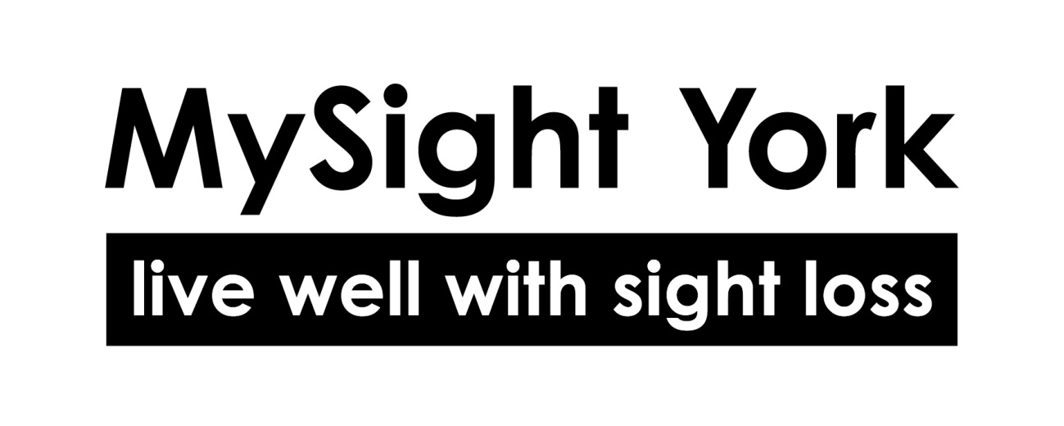
Job Description

Title: Fundraiser
Salary: £28,142 for 37 hours per week
Hours: 25 hours per week (Monday–Friday, 10am–3pm, flexible for events)
Location: MySight York HQ (Walmgate, York)
Reporting to: Chief Executive

Overview

MySight York is a hard-working local charity supporting people to live well with sight loss. We are a small but mighty team with a big ambition, to build a York where people with sight loss can live independently, equally, and without barriers.

We work alongside over 1,700 people every year, providing emotional support, expert advice, accessible services, and a welcoming community. Volunteers, fundraisers, and supporters play a huge part in helping us reach more people and deliver our vital services.

As a Fundraiser, you will play a key role in generating income to support our work. You’ll work across community fundraising, individual giving, events, local partnerships and supporter acquisition. You’ll have the chance to build relationships, organise engaging activities, and help us connect with people who want to make a difference.

This is a varied and rewarding role with flexibility and plenty of opportunity to develop your fundraising skills as part of a friendly and ambitious team.

Duties and Responsibilities
- Plan, promote, and deliver community fundraising and awareness events.
- Develop relationships with individuals, schools, community groups and local businesses to generate income and in-kind support.
- Support the delivery of individual giving campaigns, including digital appeals and regular giving.
- Manage and grow our network of local supporters and fundraisers, including “Charity of the Year” partnerships.
- Work with colleagues and volunteers to ensure events and campaigns are well supported and represent MySight York positively.
- Maintain accurate fundraising records and process donations in line with GDPR and fundraising regulations.
- Contribute ideas and feedback to help improve our fundraising and supporter engagement.
- Support the development of new fundraising materials and marketing content (with support from the wider team).
- Attend occasional evening or weekend events (with advance notice and time off in lieu).
- Carry out other reasonable duties as required by the Chief Executive.

Person specification

Qualifications | Essential | Desirable
GCSE Maths and English or equivalent
Qualification in fundraising, marketing, or communications
Skills and experience
Experience in fundraising, sales, marketing or customer service
Strong communication and interpersonal skills
Confidence in engaging with the public and building relationships
Good organisational and time management skills
Ability to use Microsoft Office and basic digital tools
Experience organising events or community activities
Creative, positive and flexible approach to work
Values
Committed to MySight York’s values and user-led ethos
Passionate about making a difference in your local community
Commitment to inclusion, accessibility and excellent customer service

Accessibility and Application Information

This document is available in alternative formats including large print, Grade 1 or Grade 2 braille, USB, disk, or email. Please contact us if you require this.

Please note:
- We only accept CVs if a disability makes completing an application form difficult. Otherwise, all applicants must address the requirements listed in this Job Description and Person Specification.
- Due to resource limitations, we are unable to contact all applicants individually. If you have not heard from us within three weeks of the closing date, please assume your application has not been successful on this occasion. We encourage you to apply for future opportunities.

For Informal Enquiries:

Scott Jobson, Chief Executive
scott.jobson@mysightyork.org

