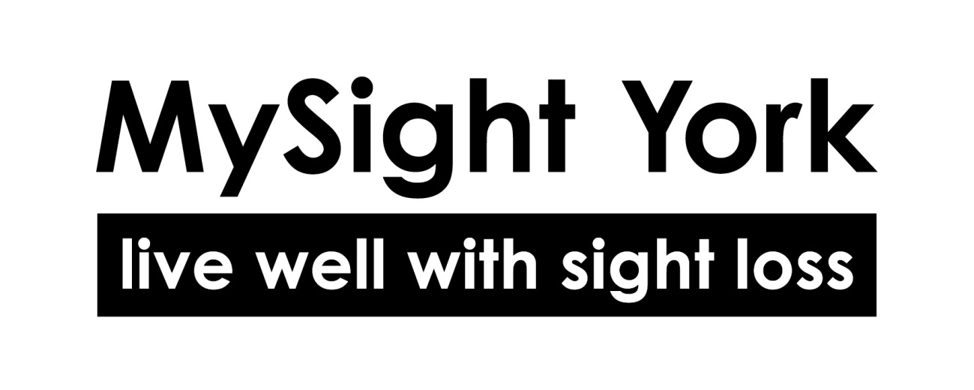
Job Description

Title: Impact & Finance Officer
Salary: £28,142 for 37 hours per week
Hours: 21 hours per week (3 days, 7 hours per day – flexible)
Location: MySight York HQ (Walmgate, York)
Reporting to: Deputy Chief Executive

Overview

MySight York is a small but mighty charity with a big ambition: to build a York where people with sight loss can live independently, equally, and without barriers. With our 2025-2028 Strategy now live, we’re strengthening our foundations, ensuring we can confidently demonstrate the value, impact, and sustainability of our work.

We are excited to introduce this brand-new role: Impact & Finance Officer. It has been created to help us prepare for enhanced SORP (Charity Statement of Recommended Practice) reporting, improve impact data collection, and support day-to-day financial processes.
You’ll work closely with the Deputy Chief Executive, Treasurer, and team leads to embed strong, efficient, and transparent systems for how we measure, report, and fund our work.
This is a fantastic opportunity for someone with experience in either charity finance or impact measurement who wants to develop both skill sets and contribute to long-term sustainability and insight-driven decision-making.

Duties and Responsibilities
Impact, Evaluation & Reporting
- Support the collection, analysis, and presentation of impact and output data across services and fundraising.
- Maintain and improve internal systems for capturing beneficiary feedback and outcomes.
- Contribute to annual impact reports, SORP-aligned reporting, and funding applications.
- Work with service leads to ensure data is meaningful, proportionate, and user-centred.
- Prepare dashboards or updates to support strategic and trustee decision-making.
- Stay up to date with changes in SORP and impact best practice, helping to embed them within the organisation.
Finance Support & Administration
- Ensure invoices are uploaded, gather income and expenditure information, confirm approvals for payment, and upload to the system for processing by external accountants.
- Track restricted/unrestricted funds and ensure accurate recording for grant or donor reporting.
- Support the Deputy Chief Executive and Treasurer with budget preparation, forecasting, and cashflow updates.
- Contribute to monthly management reports and year-end processes.
- Help maintain and develop strong financial systems, controls, and documentation.
General
- Support the development of monitoring frameworks for existing, new or pilot services.
- Liaise with staff and trustees to build shared understanding of impact and financial literacy.
- Champion MySight York’s values around transparency, inclusion, and user-led practice.
- Carry out other reasonable duties as required by the Deputy Chief Executive.

Person specification

Qualifications | Essential | Desirable
Qualification or training in finance, evaluation, data analysis or administration
Willingness to undertake further training in charity SORP or impact measurement
Skills and experience
Experience of managing or supporting financial processes in a charity or small organisation
Strong data collection, analysis and reporting skills
Experience producing clear reports or summaries for internal or external use
Good knowledge of Microsoft Excel or similar tools for data handling
Familiarity with Xero or other finance software
Ability to balance attention to detail with big-picture thinking
Understanding of charity impact reporting or theory of change approaches
Strong organisational and communication skills
Values
Committed to MySight York’s values and user-led ethos
Passionate about making a difference in your local community
Commitment to inclusion, accessibility and excellent customer service

Accessibility and Application Information

This document is available in alternative formats including large print, Grade 1 or Grade 2 braille, USB, disk, or email. Please contact us if you require this.

Please note:
- We only accept CVs if a disability makes completing an application form difficult. Otherwise, all applicants must address the requirements listed in this Job Description and Person Specification.
- Due to resource limitations, we are unable to contact all applicants individually. If you have not heard from us within three weeks of the closing date, please assume your application has not been successful on this occasion. We encourage you to apply for future opportunities.

For Informal Enquiries:

Scott Jobson, Chief Executive
scott.jobson@mysightyork.org

