
Recruitment Information Pack

Communications Officer (Fixed term)

14 hours per week

Welcome to York Travellers Trust!

Thank you so much for your interest in working with us.
In this pack you should find all the information you need to find out what we’re about.

This includes:
- More about us, what we believe in and our values
- The job description and person specification
- What we expect from our staff
- What you can expect from us
- Our application process

York Travellers Trust

Founded in 1999 York Travellers Trust (YTT) is the longest running registered charity within the United Kingdom that works primarily with Gypsy and Traveller Communities (GTC). Based in York and surrounding areas, we're here to support members of the GTC with various topics such as finance, education, health, and experiences of discrimination. Our aim is to improve their physical and mental well-being and dispel mistruths about the GTC within the local community, improving the lives of GTC and those they interact with.

For many years YTT only operated with a sole employed worker. Through the mid-2010s a Big Lottery Grant allowed a growth in our work. We now have a staff of around 10 (some part-time).

Our work is underpinned through financial support a range of funders, the larger is which the National Lottery Community Fund. This year our grant with Lottery was renewed for another 3 years. We also have funding from the Esmee Fairbairn that underpins our move to a more sociocratic way of working.

In 2024 the trustees and staff spend some time thinking through our strategy for the next 4 years and how we work together. We created this graphic to summarise our aims for the next few years:

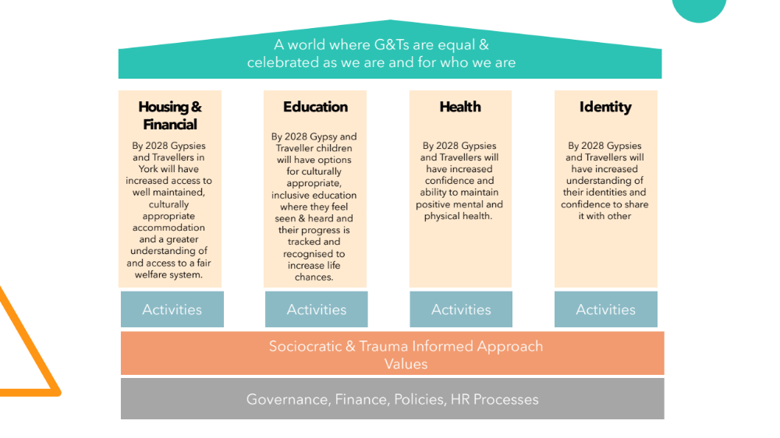

A note from our CEO
Welcome to York Travellers Trust
At York Travellers Trust (YTT), we believe that work should be meaningful, community-driven—and yes, even fun.
As the UK’s longest-running charity dedicated to Gypsy and Traveller Communities, we’re proud to stand shoulder to shoulder with the people we serve, creating real change through support in housing, education, health, advocacy, and more.
We’re a small, skilled, and spirited team, guided by values of respect, inclusion, and equity. We work hard, laugh often, and genuinely enjoy what we do—because we know that when people are happy and supported in their roles, great things happen.
We’re also on a journey towards a sociocratic way of working—a more democratic and inclusive approach where decision-making is shared and every voice matters. For us, staff wellbeing and joy at work aren’t add-ons—they’re central to how we operate.
Now, we’re looking for a Communications Officer to join our small but growing team. We are looking for someone who can strengthen our voice and build trust with our community, partners, and the wider public by telling our stories.
If you’re passionate about equity, collaboration, and driving real-world change for Gypsy and Traveller Communities - welcome home.
If you would like to know more about the role, please email Karenweaverconsulting@gmail.com
We look forward to receiving your application.
Best wishes

Violet Cannon
Chief Executive

What our staff and volunteers say about working for us…
“With the wellbeing service, we're constantly rethinking the offer, looking at it and going okay, well, this hasn't worked but that has, so we need to think differently. The wellbeing circle's been amazing in terms of that – informing how we shape services going forward.”

“The people we work with are feeling invested in and some are then investing in what we’re doing.”

“A lot of services discharge clients if they miss consecutive appointments or behave a certain way. But we decided to scrap these rules and consequences for behaviour as often this can be a punitive experience for people if they have mental health issues. I recognise that all behaviour is communication, and my approach is, “come as you are, and I’ll meet you there”. Being person centred, I have got to be prepared to meet each person where they are at. Generally, human beings seek connection and safety, so if a person can’t address those needs, and are not showing up, we have to be curious about what are the barriers or conflict to that. Whilst we acknowledge that process and structure are part of any ethically supportive environment, we have removed the issue of morality and judgement. I’m able to still be here so people can come back when they feel safe and ready. A sense of autonomy and self-agency goes a long way to build trust. Not just trust between me and ‘client’ but trust within the client, to trust themselves. Which is an issue for those with post-traumatic stress disorder (PTSD) and complex post-traumatic stress disorder (C-PTSD) or traumatic histories. Which impacts self-esteem and confidence. This knowledge [of the trauma people have experienced and how that can lead to certain behaviours] has shaped the service we offer and contributed to us looking at becoming a trauma informed organisation.”

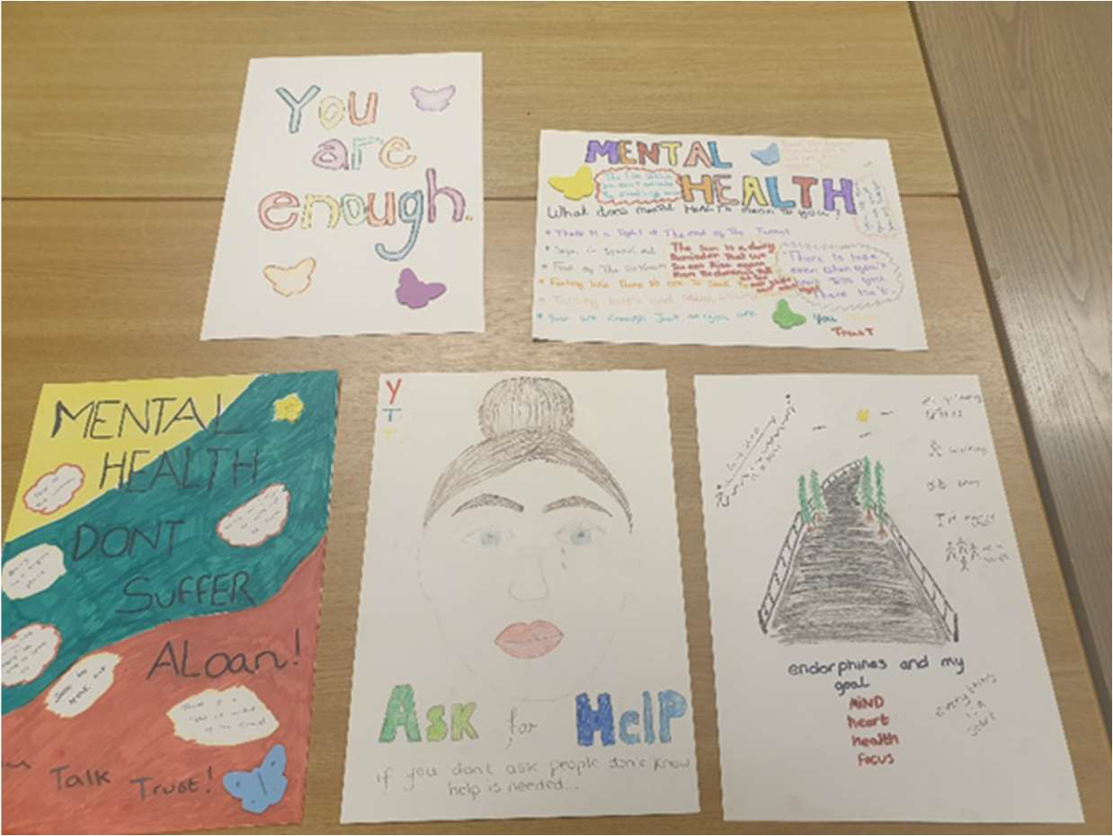
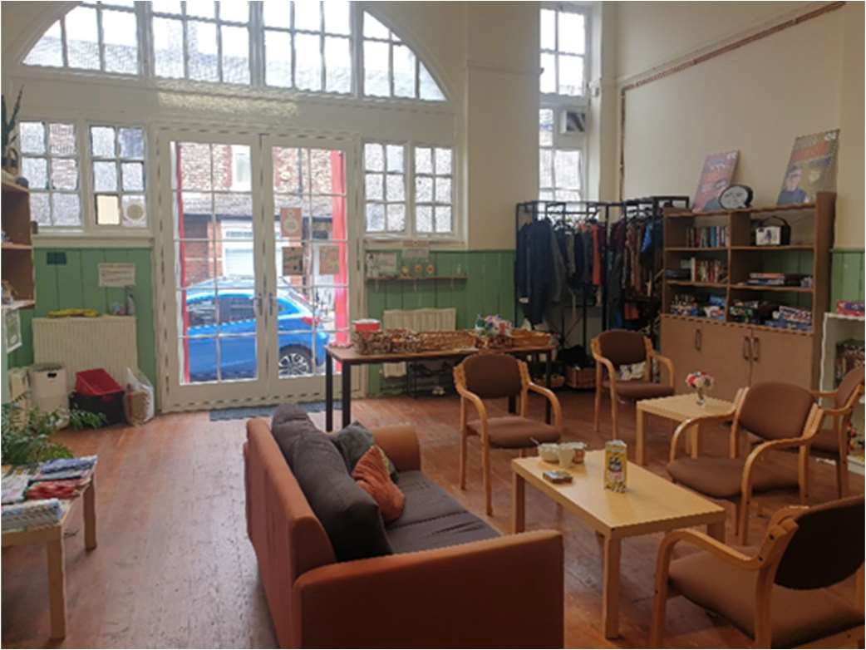

“Initially, I began volunteering at YTT’s food bank because I was in the early stages of recovering from mental health issues and felt that I wasn't ready for employment. Additionally, I contributed to the Olio food app and had leftover food, so I decided to bring it to YTT. This is how my involvement with YTT began. I have dedicated over 3 years to volunteering at YTT, which has allowed me to rebuild my confidence and collaborate with others by volunteering once a week. Due to my anxiety and poor health, I used to be quite isolated and rarely went out. However, the team at YTT immediately made me feel like a valued member. As my confidence grew, I started engaging with clients at the food bank, making them feel welcome by having conversations and offering them a cup of tea in YTT’s public living room. I also began assisting other staff and volunteers in distributing food and ensuring fair sharing. Currently, I am employed by another charity and running my own written courses, but I continue to volunteer at YTT’s food bank once a week. I find this experience enjoyable, and it helps me establish connections within my local community.”

“On a Thursday we are working with six young people who come in and work on their functional skills. We have seen rewarding outcomes, as they have grown in confidence. Not just within their functional skills, but also with talking to people and each other as well. They were invited to a primary school where they gave a talk to young people who are in mainstream education of some of the things they faced when they were in that environment and how it made them feel. This went down very well, and they went on to been invited to another school, this has built their self-confidence no end. The young people also ran a stall at an event we held in which they had a small amount of money to buy resources with and then sell their product to people. Any money they made went towards a trip of their choosing. I am so proud that we are part of helping them to become confident adults within their own community. We hope to refine and develop our offer for EHE young people over the next year to create clear pathways and holistic support which includes wellbeing support and vocational skills development.”

Job Title: Communications Officer
Reports to: Deputy Chief Executive
Direct Reports: None
Salary: £27,529 per annum pro-rata (Actual salary £10,416 working 14 hours per week)
Fixed term until March 2028 (extension dependent upon funding)
Location: York/Hybrid

Role Overview:

We are looking for a proactive, compassionate, and creative Communications Officer to lead on our external and internal communications.
You will help strengthen our voice and build trust with our community, partners, and the wider public by telling our stories.
In this role, you’ll manage our social media channels, creating content and developing campaigns. You'll oversee our website and digital presence. You will work with the staff team and community members to produce accessible resources. You will support events that bring communities and stakeholders together.
This role is perfect for someone who thrives in a small charity environment and wants to make a difference.
Key Responsibilities
- Lead the charity’s communications strategy, with the key aims of being professional and approachable. This will include social media, newsletters, website content, and printed materials.
- Work with clients and staff to gather evidence to share with key stakeholders, including case studies.
- Develop culturally sensitive, accessible, and inclusive communications that reflect the values and experiences of Gypsy and Traveller communities.
- Work with the team to raise awareness of issues affecting our community through campaigns, events, and partnerships.
- Build and maintain strong relationships with community members, partner organisations, and stakeholders.
- Support the planning and promotion of events, both online and in-person.
- Monitor and evaluate engagement across platforms, using insights to refine and improve communications activity.
- Ensure the charity’s messaging is consistent and empowering across all channels.
- Respond with empathy and professionalism when engaging with members of the community, signposting to appropriate services where needed.
About You
We know that skills and experience come in many forms. We value lived experience as highly as professional expertise.
Essential skills and experience:
- Good written and verbal communication skills. The ability to tailor messages for different audiences.
- Experience managing social media platforms (especially Facebook and Instagram).
- Ability to create compelling content, including graphics, stories, and campaigns.
- Strong organisational skills and the ability to work independently and manage multiple projects.
- A commitment to equality, diversity, and inclusion.
- Cultural sensitivity and a willingness to learn about Gypsy and Traveller communities.
Desirable:
- Experience working in a charity, community, or campaigning environment.
- Knowledge of WordPress or similar website content management systems.
- Experience using design tools such as Canva or Adobe Creative Suite.
- Lived experience of Gypsy or Traveller heritage. or experience working with these communities.

Application Process
We are committed to ensuring that our recruitment process is inclusive and accessible. If you require any adjustments to apply or take part in the selection process, please let us know.
We particularly welcome applications from members of the Gypsy and Traveller communities.
Initially please complete the application by following the link on Hireful, however, if you struggle with this, please do let us know and we will discuss with you a way for you to apply.
If you would like to arrange an informal chat, please email Karen Weaver, HR Consultant on karenweaverconsulting@gmail.com
Once you’ve submitted your application, we will compare your application to what we’re looking for with our person specification, and if they’re a good fit we’ll contact you for an interview.
References
If you are offered the role, we will require the name and address of at least two referees from whom York Travellers Trust may seek information regarding your suitability for employment. References must include your current employer and any previous employers you have worked for in the last three years (or, if you are a student, your school, college or university). It would be helpful if you would supply an email address wherever possible. Confirmed offers of employment will only be made following receipt of satisfactory references. Referees will not be contacted without your prior approval.
General Data Protection Regulation (GDPR)
In signing and submitting the various forms which make up your application you will be giving your consent to York Travellers Trust storing and using the information you provide in accordance with data protection regulations. However, none of the personal information you provide will be shared with any other body outside of York Travellers Trust and our HR Consultant.
DBS Check
Please note this role requires a DBS check.
Closing Date for applications: 26 November 2025
Interview date: TBC
What our staff can expect from working with us
We’re a friendly bunch, who are passionate about helping and supporting vulnerable people, we love a challenge and thrive on hard work. So, you’ll be joining a team of likeminded people working together for a common cause. Whether it’s tea and cake in our meeting room, or a quick catch up on Teams you can be assured of joining a welcoming organisation with wellbeing in mind.
We offer a range of benefits:
- Flexible Working Arrangements – Please check role requirements at interview
- Annual leave – 33 days annual leave (including bank holidays). All leave is pro-rated for part time employees. We also offer additional compassionate and special leave (including carers leave).
- Pension contribution – We have Defined Contribution Pension Scheme provided by the Pensions Trust.
- Learning and Development opportunities – We are keen to provide all employees with the skills and learning they need to successfully deliver their roles and develop their careers with York Travellers Trust
- Working in a values-based organisation – We are constantly trying to evolve and find ways to live our values. This means sometimes we will all get it wrong, and we will all learn together

