Mindful Movement Group Facilitator – Freelance Facilitator Tender

Introduction – St Nicks Nature Based Wellbeing programme offers a range of activities to help people connect with nature and with one another for their physical and mental wellbeing. We are seeking a freelancer to lead a Mindful Movement course, or potentially multiple courses, offering our participants a chance to improve their physical and mental wellbeing, whilst connecting to nature and others.

Mindful Movement could involve activity such as yoga, Nordic walking, tai chi, strength and balance – we are open to considering any suggested gentle physical activity, but we would prefer to deliver the sessions outdoors (weather permitting) on our local nature reserve wherever possible.

The ideal person will be qualified and insured to undertake the physical activity and would have experience of independent facilitation of groups, and of ensuring that everyone feels fully able to participate in the activity.

Key dates:
Closing date for expressions of interest: Wednesday 13 May at noon
Interview date: Tuesday 19 / Wednesday 20 May

Project information

Project scope – Design and independently facilitate between one and three 6-week long Mindful Movement courses for up to 12 participants, each session to last for a 1-hour duration. Sessions to be delivered at the St Nicks Environment Centre and on our local nature reserve, and any other locations by mutual agreement.

We have received funding to run a total of three six-week long Mindful Movement courses. We are open to considering any type of gentle physical activity as part of the course, or potentially a mix of different activities within that course if a freelancer was able to offer this. Please indicate in your application if you would prefer to deliver one course, or two or three. However, we may choose multiple freelancers to run different activities.

You would be expected to work with members of the Nature Based Wellbeing team at St Nicks to arrange course dates and room bookings, undertake monitoring of participants wellbeing and satisfaction at the beginning and end of each course to report back to our funders, and to adhere to St Nicks policies and processes to maintain confidentiality and safeguard the participants in the group activities you run. Your main point of contact will be the Nature Based Wellbeing Manager.

Timeline – delivery to take place on mutually agreed dates and all courses to be completed by April 2027.

Additional requirements – ideally the freelancer would have DBS clearance or be willing to undertake a DBS check before commencing delivery with us, would have any relevant professional qualifications for undertaking the activity specified, and they will also require public liability insurance, and we would keep a copy of that document on file. If you do not have insurance in place, please have a conversation with us about this.

Contract and budget information

Contract – you will be expected to sign a Service Level Agreement with us, setting out delivery expectations, commencement dates, fees and expenses, invoice and payment arrangements, taxation and insurance, copyright/patent, evaluation and monitoring and a work schedule.

Budget - the project has a fixed budget of £75 per session allocated for the preparation and facilitation of that session, and we would expect the delivery of all work within the project scope to be delivered within this budget.

About St Nicks
We are St Nicks, a local environmental charity with a mission to “build and connect flourishing communities through urban greenspace generation, nature-based wellbeing and sustainable living”. Based at St Nicks Environment Centre hidden behind residential properties in the Tang Hall area of York, we have a thriving 24-acre nature reserve that is free to explore 24 hours a day 365 days a year. Our volunteer team help us maintain and manage our reserve for the benefit of people and wildlife.
In addition to managing the local nature reserve (LNR), we have three key pillars to our work:
- Green Corridors York strives for “more, bigger, better and more joined up” green spaces. Conserving nature whilst supporting our communities. As a city, we can work together to reduce pollution, challenge harmful developments and improve land management.
- Our Nature-Based Wellbeing team deliver both education and mental health support services. At St Nicks we all see and feel the benefits of being outdoors and connected to nature. These benefits can be physical, mental or a combination of both! Our Nature-Based Wellbeing team run a series of Ecotherapy groups to help adults find this nature-connectedness. 92% of Ecotherapy participants told us that these activities meant that they noticed and sought out nature more in their daily lives. We run education and youth activities which capture the imagination of children and families, inspiring them to connect with the natural world and to live more sustainably.
- Sustainability is at the heart of everything we do at St Nicks. When we talk about sustainability, we are looking to ensure we are doing the least harm possible. Whether that is relating to human, social, financial or environmental. Our Waste & Sustainability team collect recycling, carry out waste audits and run events across the city. Together our teams work to make York a more sustainable city.


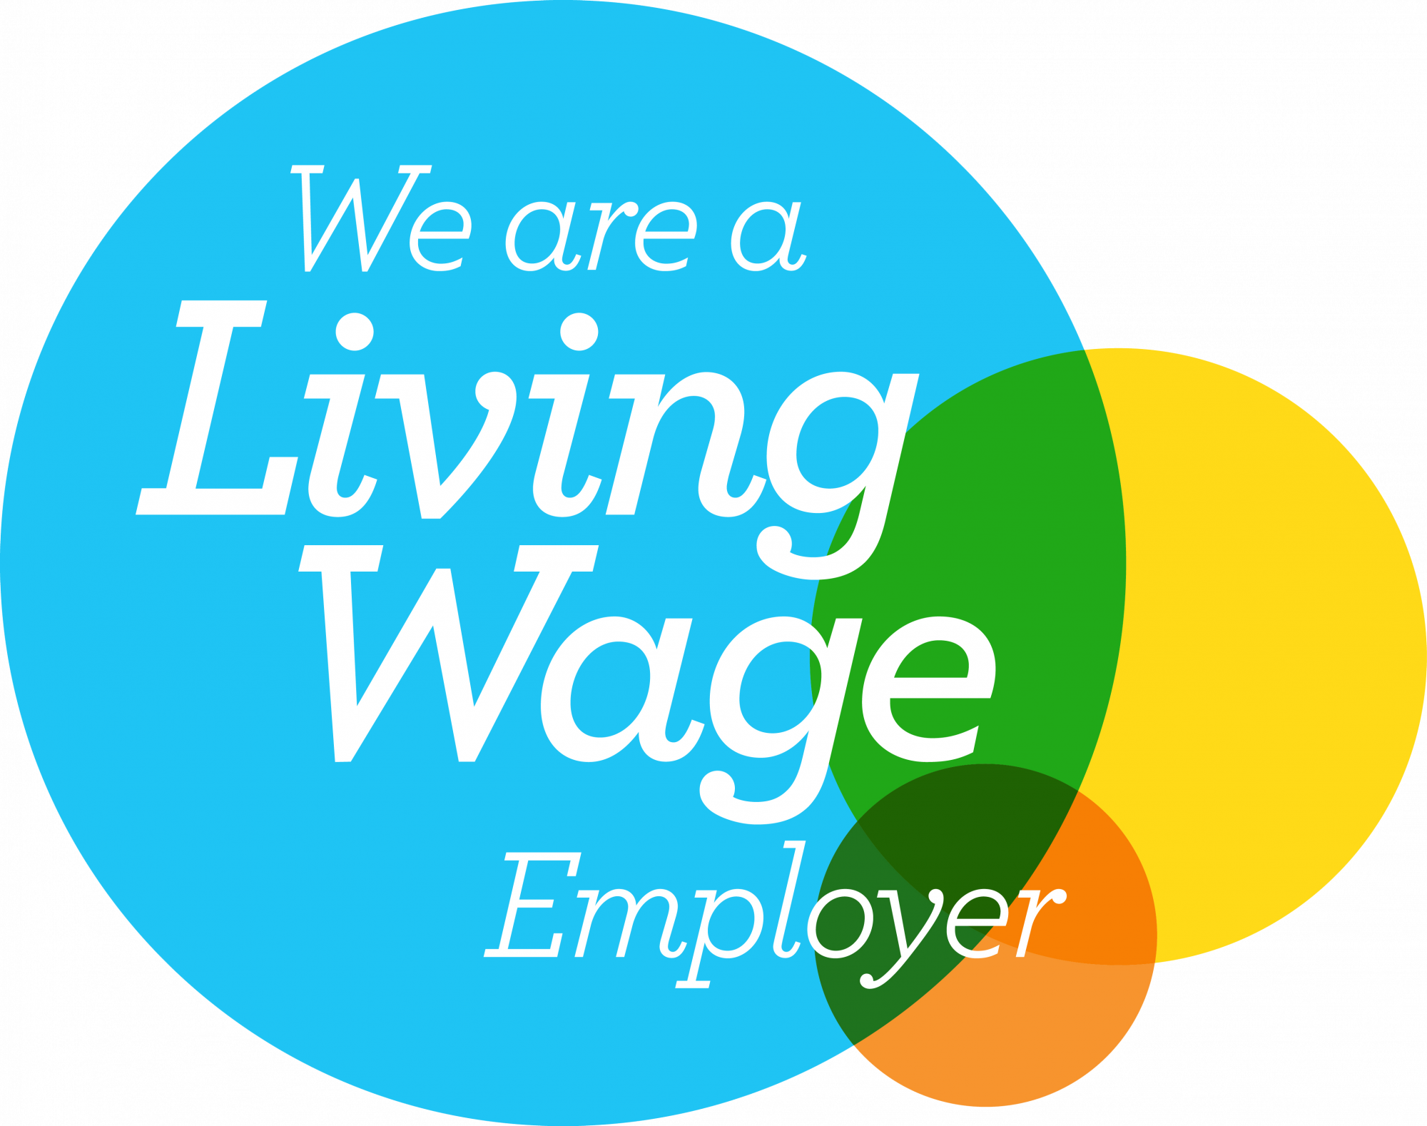

Our values
Collaboration – Our approachability and inclusiveness ensure that everyone who is affected by our work is involved in shaping it.
Integrity – We are honest, inclusive and have respect for all life through our ethics, authenticity and commitment.
Innovation – We are committed to constructively exploring ideas that help us get closer to our vision by doing things differently and taking pioneering approaches, recognising the learning and development that comes with this path.
Professionalism – All of our actions to our beneficiaries, stakeholders and each other demonstrate our mutual respect, competence, proactivity and the way we make a difference.

Submitting an expression of interest

Process – If you would like to submit an expression of interest to deliver this project, please submit your CV and a covering letter detailing relevant experience and outlining your approach to delivery, and an EDI form to anna@stnicks.org.uk.

Deadline for expressions of interest – Wednesday 13 May at noon

Interview dates - Tuesday 19 / Wednesday 20 May

For an informal conversation about the project and role please contact the Nature Based Wellbeing Manager Anna Perrett.

Anna Perrett
Nature Based Wellbeing Manager
anna@stnicks.org.uk
07926 072858

